PRODUCT REQUIREMENT DOCUMENT (PRD)

AI-Powered Smart Research & Learning Assistant

An Intelligent Document Analysis and AI Learning Platform using Retrieval-Augmented Generation (RAG)

Submitted By
Student Name: [Your Name]
Roll Number: [Your Roll Number]

Department
Department of Computer Science & Engineering (Business Systems)

College
[Your College Name]

Project Guide
Guide Name: [Faculty Name]

Academic Year
2026 – 2027

Document Version
Version: 1.0
Document Type: Product Requirement Document (PRD)
Prepared On: August 2026
Status: Initial Release

Project Description
The AI-Powered Smart Research & Learning Assistant is an intelligent web-based platform that enables users to upload academic documents (PDF, DOCX, PPTX, TXT), interact with them through an AI-powered chatbot, generate concise summaries, study notes, quizzes, flashcards, mind maps, translations, and audio explanations. The system leverages Retrieval-Augmented Generation (RAG) to provide context-aware, citation-backed responses while minimizing AI hallucinations, making learning faster, smarter, and more reliable.

Prepared for Academic Project Submission

2. Executive Summary

2.1 Project Overview
The AI-Powered Smart Research & Learning Assistant is an intelligent web-based platform designed to simplify the way users study, research, and interact with digital documents. Instead of manually reading lengthy PDFs, presentations, or documents, users can upload their study materials and communicate with an AI assistant that understands the document's content.
The platform utilizes Retrieval-Augmented Generation (RAG) to retrieve relevant information from uploaded documents before generating responses. This approach enables context-aware, accurate, and citation-backed answers while significantly reducing AI hallucinations. In addition to AI-powered document chat, the system provides multiple learning tools such as automatic summaries, notes generation, quizzes, flashcards, mind maps, translations, simplified explanations (ELI5), and text-to-speech.
The primary objective is to create an all-in-one AI learning platform that improves productivity, enhances understanding, and supports efficient knowledge acquisition for students, researchers, teachers, and professionals.

2.2 Problem Statement
Traditional methods of studying large academic documents are time-consuming and inefficient. Students and researchers often struggle to locate specific information within lengthy PDFs, prepare concise notes, revise important topics, or verify the accuracy of AI-generated answers.
General-purpose AI chatbots also have several limitations when used for document-based learning:
- They cannot directly understand the user's uploaded study materials.
- They may generate inaccurate or hallucinated information.
- They usually do not provide references or citations.
- Users spend significant time manually searching through documents.
- There is no integrated solution that combines document understanding with AI-powered learning tools.
These challenges reduce learning efficiency and increase the time required for research and revision.

2.3 Proposed Solution
The proposed solution is an AI-powered research and learning platform that combines document processing, semantic search, and Large Language Models through Retrieval-Augmented Generation (RAG).
Users can securely upload documents, which are automatically parsed, segmented into smaller chunks, converted into vector embeddings, and stored in a vector database. When a question is asked, the system retrieves the most relevant document sections and provides context-aware answers supported by citations.
Beyond document-based question answering, the platform includes an integrated AI Study Suite capable of generating:
- AI-powered document summaries
- Smart study notes
- Practice quizzes
- Flashcards
- Mind maps
- Simplified explanations (ELI5)
- Translation into multiple languages
- Text-to-Speech audio
This creates a comprehensive AI learning environment within a single application.

2.4 Business Value
The proposed system delivers significant value to both educational institutions and individual learners by reducing study time and improving learning outcomes.
Key business benefits include:
- Faster research and document analysis
- Improved learning efficiency
- Higher productivity through AI automation
- Reduced time spent searching documents
- Reliable, citation-backed AI responses
- Better knowledge retention through quizzes and flashcards
- Scalable architecture suitable for future commercial deployment
- Foundation for an AI-based educational SaaS platform

2.5 Objectives
The major objectives of this project are:
- Develop an intelligent AI-powered document analysis platform.
- Enable secure upload and management of multiple document formats.
- Implement Retrieval-Augmented Generation (RAG) for context-aware question answering.
- Provide citation-supported AI responses to improve reliability.
- Generate automated summaries, notes, quizzes, flashcards, and mind maps.
- Improve learning efficiency through AI-assisted study tools.
- Design a secure, scalable, and modular architecture using modern technologies.
- Create a user-friendly interface for students, researchers, teachers, and professionals.
- Minimize AI hallucinations by grounding responses in uploaded documents.
- Build a strong foundation for future expansion into a full-scale AI learning ecosystem.

3. Product Vision

3.1 Vision
To build an intelligent AI-powered learning platform that transforms the way people study, research, and interact with documents by providing fast, accurate, and context-aware information. The platform aims to make learning more efficient through Retrieval-Augmented Generation (RAG) and advanced AI capabilities while ensuring reliable, citation-backed responses.

3.2 Mission
The mission of the AI-Powered Smart Research & Learning Assistant is to simplify knowledge acquisition by combining document management, semantic search, and Artificial Intelligence into a single platform. The system enables users to upload documents, ask questions in natural language, generate learning materials, and improve productivity through AI-assisted study tools.

3.3 Target Users

Students
Students can upload lecture notes, textbooks, assignments, research papers, and study materials to:
- Chat with uploaded documents using AI.
- Generate concise summaries and study notes.
- Create quizzes and flashcards for revision.
- Understand difficult concepts using simplified (ELI5) explanations.
- Save time during exam preparation.

Researchers
Researchers can use the platform to:
- Analyze research papers efficiently.
- Retrieve relevant information using semantic search.
- Obtain citation-backed answers from uploaded documents.
- Summarize lengthy academic papers.
- Improve literature review and research productivity.

Teachers
Teachers can utilize the system to:
- Prepare lecture materials quickly.
- Generate summaries and classroom notes.
- Create quizzes for assessments.
- Simplify complex topics for students.
- Organize educational resources in one platform.

Professionals
Professionals can leverage the platform to:
- Analyze technical documentation and reports.
- Quickly retrieve important information from large documents.
- Generate summaries for meetings and presentations.
- Improve workplace productivity through AI-assisted document understanding.
- Learn new topics efficiently using AI-generated study materials.

4. Problem Statement
In today's digital era, students, researchers, teachers, and professionals work with a large number of documents such as textbooks, research papers, lecture notes, reports, and technical manuals. Finding relevant information from these documents is often time-consuming and requires extensive manual effort. As the volume of digital content continues to grow, efficiently understanding and extracting knowledge from lengthy documents has become a major challenge.
Although Large Language Models (LLMs) have improved access to AI-powered assistance, they still face limitations when answering questions based on user-specific documents. Traditional AI chatbots generally lack document awareness, may produce hallucinated responses, and often fail to provide reliable citations. This reduces trust in AI-generated information, especially in academic and research environments.
The project aims to address these challenges by developing an AI-Powered Smart Research & Learning Assistant that combines document processing with Retrieval-Augmented Generation (RAG). The system enables users to upload documents, ask questions in natural language, and receive context-aware, citation-backed responses. It also provides AI-powered study tools such as summaries, notes, quizzes, flashcards, mind maps, translations, and simplified explanations to improve learning efficiency.

Current Problems

4.1 Information Overload
Students and professionals often work with hundreds of pages of study materials and research documents. Identifying relevant information manually is slow, repetitive, and inefficient.

4.2 Long PDFs and Documents
Reading lengthy PDFs, books, reports, and research papers requires significant time. Important concepts are often difficult to locate quickly, reducing overall productivity.

4.3 Difficult Revision
Preparing concise revision materials from multiple documents is a manual and time-consuming process. Users frequently create notes and summaries themselves, which increases workload during exams or project deadlines.

4.4 No Context-Aware Search
Traditional keyword-based search methods cannot understand the actual meaning or context of a user's query. As a result, users may receive irrelevant search results even when the required information exists within the document.

4.5 LLM Hallucination
General-purpose AI models may generate incorrect or fabricated information when they do not have access to the user's documents. This limits their reliability for academic research and professional decision-making.

4.6 No Citation Support
Most AI chat systems provide answers without referencing the exact source from which the information was obtained. The absence of citations makes it difficult for users to verify the accuracy and authenticity of AI-generated responses.

Need for the Proposed System
To overcome these limitations, an intelligent document-based learning platform is required that can:
- Understand uploaded documents instead of relying only on general knowledge.
- Retrieve relevant document content using semantic search.
- Generate accurate, context-aware, and citation-backed answers.
- Reduce AI hallucinations through Retrieval-Augmented Generation (RAG).
- Automate the creation of summaries, notes, quizzes, flashcards, and other study materials.
- Improve productivity and make learning faster, smarter, and more efficient.

5. Goals & Objectives
The primary goal of the AI-Powered Smart Research & Learning Assistant is to develop an intelligent and scalable platform that enables users to interact with uploaded documents using Artificial Intelligence. By integrating Retrieval-Augmented Generation (RAG) with Large Language Models (LLMs), the system aims to deliver accurate, context-aware, and citation-backed responses while providing AI-powered learning tools to improve productivity and knowledge retention.

5.1 Functional Goals
The functional goals of the project are:
- Develop a secure user authentication and authorization system.
- Enable users to upload and manage documents in multiple formats (PDF, DOCX, PPTX, TXT).
- Automatically parse, process, and chunk uploaded documents.
- Generate vector embeddings and store them in a vector database for semantic retrieval.
- Implement Retrieval-Augmented Generation (RAG) for intelligent document-based question answering.
- Provide citation-backed AI responses using retrieved document context.
- Maintain chat history for future reference.
- Generate AI-powered summaries, study notes, quizzes, flashcards, and mind maps.
- Support translation and simplified explanations (ELI5) for better understanding.
- Convert generated content into speech using Text-to-Speech (TTS).
- Allow users to manage their profile, uploaded documents, and AI conversations.

5.2 Business Goals
The business goals of the project include:
- Reduce the time required for document analysis and information retrieval.
- Improve learning efficiency through AI-assisted study tools.
- Increase user productivity by automating repetitive learning tasks.
- Deliver trustworthy AI responses through document-grounded retrieval and citations.
- Build a scalable platform capable of supporting future SaaS deployment.
- Create a modular architecture that allows easy integration of additional AI features in future releases.
- Provide an innovative educational technology solution for academic and professional users.

5.3 Learning Goals
The project also serves as a learning opportunity to gain practical experience in modern software development and Artificial Intelligence technologies. The learning objectives include:
- Understand the architecture and implementation of Retrieval-Augmented Generation (RAG).
- Learn document parsing, chunking, and semantic search techniques.
- Integrate Large Language Models (LLMs) into real-world applications.
- Develop RESTful APIs using Spring Boot.
- Implement secure authentication using JWT and Spring Security.
- Work with MongoDB and vector databases such as Qdrant.
- Design scalable backend architectures following industry best practices.
- Apply Docker and containerization for deployment.
- Improve full-stack development skills by integrating frontend, backend, database, and AI components.

5.4 Success Criteria
The project will be considered successful if it achieves the following outcomes:
- Users can securely register, log in, and manage their accounts.
- Documents are uploaded, processed, and indexed successfully.
- The RAG pipeline retrieves relevant document content with high accuracy.
- AI generates context-aware answers supported by citations.
- Study tools such as summaries, notes, quizzes, flashcards, and mind maps function correctly.
- The system provides fast response times and a smooth user experience.
- Data is protected using secure authentication and authorization mechanisms.
- The application is scalable, maintainable, and deployable using modern DevOps practices.
- The platform successfully demonstrates the practical use of AI and RAG for intelligent document analysis and learning assistance.

7. Functional Requirements
The functional requirements define the core features and capabilities of the AI-Powered Smart Research & Learning Assistant. The system is divided into five major modules, each responsible for a specific set of functionalities.

Module 1: Authentication & Authorization
This module manages user identity, authentication, and secure access to the application.

Features

1.1 User Registration (Signup)
- Register using name, email, and password.
- Validate user input.
- Encrypt passwords using BCrypt.
- Prevent duplicate email registration.

1.2 User Login
- Authenticate users using email and password.
- Generate JWT access token after successful login.
- Maintain secure user sessions.

1.3 JWT Authentication
- Validate JWT for every protected API request.
- Allow access only to authenticated users.
- Automatically reject invalid or expired tokens.

1.4 Logout
- Remove user session on the client side.
- Invalidate refresh token (if implemented).

1.5 Role-Based Access Control (RBAC)
- Support different user roles (User, Admin).
- Restrict administrative operations.
- Protect sensitive APIs using role-based authorization.

Module 2: Document Management
This module handles document upload, storage, processing, and management.

Features

2.1 Document Upload
- Upload PDF, DOCX, PPTX, and TXT files.
- Validate file type and size.
- Store document metadata.

2.2 Document Parsing
- Extract text from uploaded documents.
- Handle different document formats.
- Clean and normalize extracted text.

2.3 Document Chunking
- Divide extracted text into smaller chunks.
- Apply overlapping chunk strategy for better retrieval.
- Prepare chunks for embedding generation.

2.4 Metadata Management
- Store file name, upload date, size, owner, and document type.
- Track document processing status.

2.5 Document Viewing
- Display uploaded documents.
- View document metadata.
- Search uploaded documents.

2.6 Document Deletion
- Delete documents from storage.
- Remove associated embeddings from the vector database.
- Delete related chat history (optional).

Module 3: RAG Engine
This module implements the Retrieval-Augmented Generation (RAG) pipeline for intelligent document-based question answering.

Features

3.1 Embedding Generation
- Convert document chunks into vector embeddings.
- Generate embeddings using an AI embedding model.

3.2 Vector Storage
- Store embeddings in the Qdrant vector database.
- Associate vectors with document metadata.

3.3 Semantic Search
- Retrieve the most relevant document chunks.
- Rank results based on vector similarity.
- Return top-k relevant chunks.

3.4 Prompt Builder
- Combine retrieved document chunks with the user's query.
- Generate optimized prompts for the LLM.

3.5 AI Chat
- Allow users to ask questions about uploaded documents.
- Generate context-aware responses.
- Support multi-turn conversations.

3.6 Citation Generation
- Display the source document and relevant section for each answer.
- Improve transparency and answer verification.

3.7 Chat History
- Save previous conversations.
- Allow users to revisit earlier chats.
- Maintain conversation context.

Module 4: AI Study Suite
This module provides AI-powered learning and productivity tools.

Features

4.1 AI Summary Generator
- Generate concise summaries of uploaded documents.
- Support short and detailed summary modes.

4.2 Smart Notes Generator
- Extract important concepts.
- Generate structured study notes.

4.3 Quiz Generator
- Create multiple-choice questions from documents.
- Provide correct answers and explanations.

4.4 Flashcards Generator
- Automatically generate question-answer flashcards.
- Assist with quick revision.

4.5 Mind Map Generator
- Generate hierarchical concept maps.
- Visualize relationships between topics.

4.6 Translation
- Translate generated content into multiple languages.
- Preserve meaning and context.

4.7 ELI5 (Explain Like I'm Five)
- Simplify complex concepts.
- Produce beginner-friendly explanations.

4.8 Text-to-Speech (TTS)
- Convert summaries and answers into speech.
- Support audio-based learning.

Module 5: User Profile & Settings
This module manages user information and preferences.

Features

5.1 User Profile
- View and edit profile information.
- Update personal details.

5.2 Password Management
- Change password securely.
- Validate current password before updating.

5.3 Document Dashboard
- View all uploaded documents.
- Track document status.
- Access document history.

5.4 Chat Management
- View previous AI conversations.
- Delete chat history.
- Continue existing conversations.

5.5 User Settings
- Manage application preferences.
- Configure AI response settings.
- Select preferred language (optional).
- Customize study experience.

Functional Requirement Summary
Module | Description
Module 1 | Secure user authentication, authorization, JWT, and RBAC
Module 2 | Document upload, parsing, chunking, storage, and management
Module 3 | RAG pipeline including embeddings, vector search, AI chat, citations, and chat history
Module 4 | AI-powered study tools such as summaries, notes, quizzes, flashcards, mind maps, translation, ELI5, and TTS
Module 5 | User profile, settings, document dashboard, password management, and chat history

8. User Stories
User stories describe the functional requirements from the perspective of different types of users. They help ensure that the system is designed to meet real user needs and provides a clear understanding of how each feature will be used.

8.1 Student
As a Student, I want to upload my study materials and interact with them using AI so that I can learn more efficiently and prepare for exams quickly.

User Stories
- As a student, I want to create an account so that I can securely access my documents.
- As a student, I want to upload PDF, DOCX, PPTX, and TXT files so that I can study using AI.
- As a student, I want to ask questions about my uploaded documents so that I can quickly find relevant information.
- As a student, I want AI-generated summaries to understand lengthy documents in less time.
- As a student, I want AI-generated notes for quick revision.
- As a student, I want quizzes to test my knowledge.
- As a student, I want flashcards for effective memorization.
- As a student, I want mind maps to visualize concepts.
- As a student, I want simplified (ELI5) explanations for difficult topics.
- As a student, I want citations with AI answers so that I can verify the information.
- As a student, I want to access my previous chats and uploaded documents anytime.

8.2 Researcher
As a Researcher, I want to analyze research papers efficiently so that I can save time during literature reviews and academic research.

User Stories
- As a researcher, I want to upload research papers for AI analysis.
- As a researcher, I want semantic search instead of keyword search.
- As a researcher, I want citation-backed answers for reliable information.
- As a researcher, I want concise summaries of long research papers.
- As a researcher, I want to compare information across multiple documents.
- As a researcher, I want to retrieve important findings quickly.
- As a researcher, I want to maintain chat history for future reference.

8.3 Teacher
As a Teacher, I want AI to assist in preparing learning materials so that I can spend more time teaching and less time creating content.

User Stories
- As a teacher, I want to upload lecture notes and study materials.
- As a teacher, I want AI-generated summaries for classroom preparation.
- As a teacher, I want quizzes for student assessments.
- As a teacher, I want simplified explanations for complex topics.
- As a teacher, I want organized notes for classroom use.
- As a teacher, I want citation-supported answers for academic accuracy.
- As a teacher, I want easy access to previously uploaded documents.

8.4 Admin
As an Admin, I want to manage users and system resources so that the application remains secure, reliable, and efficient.

User Stories
- As an admin, I want to manage user accounts.
- As an admin, I want to assign user roles and permissions.
- As an admin, I want to monitor uploaded documents.
- As an admin, I want to manage system settings.
- As an admin, I want to monitor application usage and performance.
- As an admin, I want to remove inappropriate or corrupted documents.
- As an admin, I want to ensure platform security and data integrity.

User Story Summary
User Role | Primary Goals
Student | Upload documents, chat with AI, generate summaries, notes, quizzes, flashcards, and revise efficiently.
Researcher | Analyze research papers, perform semantic search, obtain citation-backed answers, and improve research productivity.
Teacher | Prepare lecture materials, create quizzes, simplify complex topics, and organize educational resources.
Admin | Manage users, roles, documents, security, and overall system administration.

9. Use Case Diagram

9.1 Actors
The system consists of four primary actors:
- Student – Uploads study materials, interacts with AI, and uses learning tools.
- Researcher – Analyzes research papers, performs semantic search, and retrieves citation-backed answers.
- Teacher – Creates learning materials, quizzes, and summaries for students.
- Admin – Manages users, documents, system settings, and security.

9.2 Use Cases

Common User Use Cases
- Register Account
- Login
- Logout
- Manage Profile
- Change Password
- Upload Document
- View Documents
- Delete Document
- Ask Questions to AI
- View Chat History

AI Study Features
- Generate Summary
- Generate Notes
- Generate Quiz
- Generate Flashcards
- Generate Mind Map
- Translate Content
- Explain Like I'm Five (ELI5)
- Convert Text to Speech

Admin Use Cases
- Manage Users
- Manage Documents
- Manage Roles
- Monitor System
- View Analytics (Optional)

9.3 Relationships

Association
- Student → Upload Document
- Student → Chat with AI
- Student → Generate Study Materials
- Researcher → Upload Research Papers
- Researcher → Ask AI Questions
- Researcher → Retrieve Citations
- Teacher → Upload Notes
- Teacher → Generate Quiz
- Teacher → Generate Summary
- Admin → Manage Users
- Admin → Manage Documents
- Admin → Configure System

Include Relationships
The following use cases include additional mandatory operations:
- Upload Document <<include>> Parse Document
- Parse Document <<include>> Chunk Document
- Chunk Document <<include>> Generate Embeddings
- Ask AI Question <<include>> Semantic Search
- Semantic Search <<include>> Prompt Builder
- Prompt Builder <<include>> Generate AI Response
- Generate AI Response <<include>> Display Citation

Extend Relationships
The following optional features extend the AI Chat functionality:
- Generate Summary <<extend>> AI Chat
- Generate Notes <<extend>> AI Chat
- Generate Quiz <<extend>> AI Chat
- Generate Flashcards <<extend>> AI Chat
- Generate Mind Map <<extend>> AI Chat
- Translate Content <<extend>> AI Chat
- ELI5 Explanation <<extend>> AI Chat
- Text-to-Speech <<extend>> AI Chat
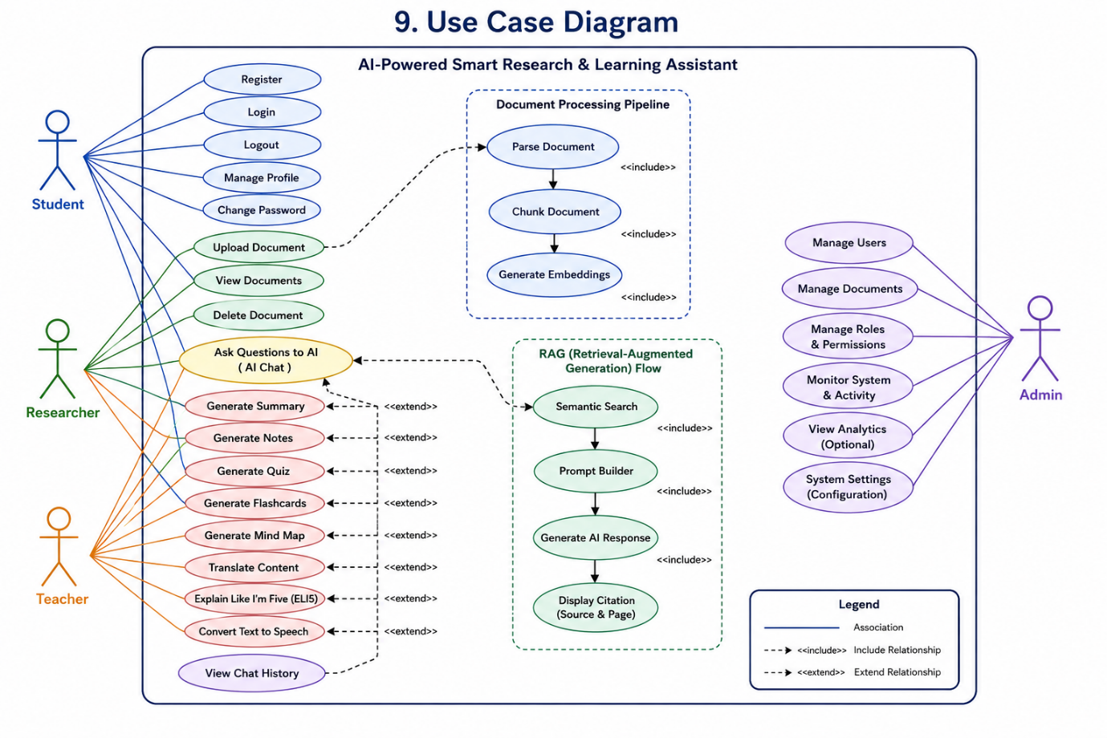

10. System Workflow
The AI-Powered Smart Research & Learning Assistant follows a structured workflow that securely processes user requests, analyzes uploaded documents, retrieves relevant information using Retrieval-Augmented Generation (RAG), and generates AI-powered learning resources.
The complete workflow consists of five major processes: User Authentication, Document Upload, Document Processing, RAG-based Question Answering, and AI Study Tools.

10.1 Login Workflow
The login workflow authenticates users and provides secure access to the application.

Workflow
- User opens the application.
- User enters email and password.
- System validates the credentials.
- Password is verified using BCrypt.
- If authentication is successful:
  - JWT Access Token is generated.
  - User session is created.
  - User is redirected to the Dashboard.
- If authentication fails:
  - Appropriate error message is displayed.
  - Login is rejected.

10.2 Document Upload Workflow
This workflow manages document upload and storage.

Workflow
- User selects a document (PDF, DOCX, PPTX, or TXT).
- System validates:
  - File format
  - File size
- Document is uploaded to the server.
- Metadata is stored in MongoDB.
- Document is forwarded for processing.
- User receives upload confirmation.

10.3 Document Processing Workflow
After a successful upload, the system prepares the document for AI retrieval.

Workflow
- Extract text from the uploaded document.
- Clean and normalize the extracted content.
- Split the document into smaller chunks.
- Generate vector embeddings for each chunk.
- Store embeddings in the Qdrant Vector Database.
- Mark the document as indexed and ready for AI interaction.

10.4 RAG Workflow
This workflow powers AI-based document question answering.

Workflow
- User asks a question.
- Query is converted into an embedding.
- Semantic search is performed in Qdrant.
- Top relevant document chunks are retrieved.
- Retrieved context is combined with the user's query.
- Prompt is sent to the Large Language Model (LLM).
- AI generates a context-aware response.
- Source citations are attached.
- Response is displayed to the user.
- Conversation is stored in Chat History.

10.5 AI Study Suite Workflow
The AI Study Suite generates learning resources from uploaded documents.

Workflow
- User selects an AI feature:
  - Summary
  - Notes
  - Quiz
  - Flashcards
  - Mind Map
  - Translation
  - ELI5
  - Text-to-Speech
- System retrieves the relevant document content.
- RAG provides contextual information.
- Prompt is created based on the selected feature.
- AI processes the request.
- Generated output is displayed to the user.
- User can download, copy, or regenerate the result.

Workflow Summary
Workflow | Purpose
Login Workflow | Authenticates users using JWT and Spring Security.
Upload Workflow | Uploads and validates study documents.
Processing Workflow | Parses, chunks, and indexes documents into the vector database.
RAG Workflow | Retrieves relevant document content and generates citation-backed AI responses.
AI Study Workflow | Generates summaries, notes, quizzes, flashcards, mind maps, translations, ELI5 explanations, and speech output.
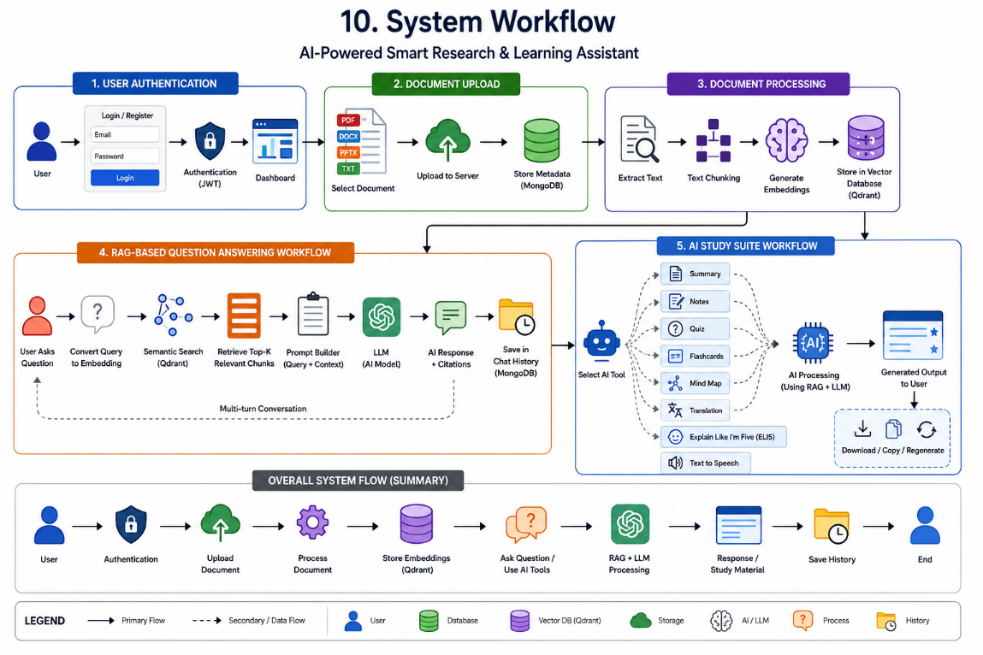

11. Architecture
The AI-Powered Smart Research & Learning Assistant follows a modular, scalable, and layered architecture. The system integrates a modern frontend, a secure Spring Boot backend, AI services, a vector database, and cloud-ready deployment components. This architecture ensures high performance, maintainability, and easy scalability while supporting Retrieval-Augmented Generation (RAG) for intelligent document understanding.

11.1 Overall Architecture
The system consists of the following major layers:

1. Presentation Layer
The Presentation Layer provides the user interface through which users interact with the application.
Components:
- React.js
- Tailwind CSS
- Axios
- JWT Authentication
- Dashboard UI
Responsibilities:
- User Registration & Login
- Document Upload
- AI Chat Interface
- Study Tools Interface
- User Profile
- Display AI Responses

2. Application Layer
The Application Layer contains the business logic of the system.
Technology:
- Java 21
- Spring Boot
- Spring MVC
- Spring Security
- JWT Authentication
- REST APIs
Responsibilities:
- Authentication
- Authorization
- User Management
- Document Management
- Chat Management
- AI Request Handling
- Prompt Construction
- Response Generation

3. AI & RAG Layer
This layer is responsible for intelligent document retrieval and AI processing.
Components:
- Document Parser
- Text Chunking
- Embedding Generator
- Qdrant Vector Database
- Semantic Search
- Prompt Builder
- Large Language Model (LLM)
- Citation Generator
Responsibilities:
- Process uploaded documents
- Generate vector embeddings
- Perform semantic retrieval
- Retrieve relevant chunks
- Generate context-aware responses
- Reduce AI hallucination

4. Data Layer
The Data Layer stores application data and vector embeddings.

MongoDB
Stores:
- Users
- Documents
- Metadata
- Chat History
- User Settings

Qdrant
Stores:
- Vector Embeddings
- Document Chunks
- Similarity Indexes

5. Infrastructure Layer
This layer manages deployment and scalability.
Components:
- Docker
- Docker Compose
- Nginx
- Environment Variables
- Linux Server / Cloud VM

11.2 Component Diagram
The system is divided into the following components:

Frontend
- Authentication UI
- Dashboard
- Document Upload
- AI Chat
- Study Suite
- Profile
↓

Backend (Spring Boot)
Modules
- Authentication Service
- User Service
- Document Service
- AI Service
- Chat Service
- Profile Service
↓

AI Engine
- Parser
- Chunking
- Embedding Service
- Semantic Search
- Prompt Builder
- LLM
- Citation Generator
↓

Databases
MongoDB
- Users
- Chats
- Documents
- Metadata
Qdrant
- Vector Embeddings
- Document Chunks

11.3 Deployment Diagram
Deployment Architecture
Client Browser
│
▼
Nginx
│
▼
React Frontend
│
REST API (HTTPS)
│
▼
Spring Boot Backend
│
┌─────┼─────────────┐
│ │ │
▼ ▼ ▼
MongoDB Qdrant LLM API
│
▼
Docker Containers
Deployment Components:
- Client Browser
- Nginx Reverse Proxy
- React Frontend
- Spring Boot Backend
- MongoDB
- Qdrant Vector Database
- External LLM API (e.g., OpenAI/Gemini)
- Docker & Docker Compose

11.4 Sequence Diagram

AI Chat Workflow
User
│
▼
Frontend
│
▼
Spring Boot API
│
▼
Semantic Search
│
▼
Qdrant
│
▼
Relevant Chunks
│
▼
Prompt Builder
│
▼
LLM
│
▼
AI Response
│
▼
Frontend
│
▼
User
Sequence Steps:
- User submits a question.
- Frontend sends the request to the backend.
- Backend converts the query into an embedding.
- Qdrant retrieves relevant document chunks.
- Backend builds a prompt using the retrieved context.
- Prompt is sent to the LLM.
- LLM generates a response.
- Backend attaches citations.
- Response is returned to the frontend.
- User views the answer.

11.5 Class Diagram
The major classes in the system are:

Entity Classes
- User
- Role
- Document
- DocumentChunk
- Chat
- ChatMessage
- EmbeddingMetadata
- UserSettings

Service Classes
- AuthService
- UserService
- DocumentService
- AIService
- EmbeddingService
- ChatService
- ProfileService

Repository Classes
- UserRepository
- DocumentRepository
- ChatRepository
- SettingsRepository

Controller Classes
- AuthController
- UserController
- DocumentController
- ChatController
- AIController
- ProfileController

Utility Classes
- JWTUtil
- PromptBuilder
- FileParser
- ChunkingUtil
- EmbeddingUtil
- CitationGenerator

Architecture Summary
Architecture Layer | Technologies / Components
Presentation Layer | React.js, Tailwind CSS, Axios
Application Layer | Java 21, Spring Boot, Spring Security, JWT
AI & RAG Layer | Parser, Chunking, Embeddings, Qdrant, Semantic Search, LLM
Data Layer | MongoDB, Qdrant
Infrastructure Layer | Docker, Docker Compose, Nginx, Linux Server

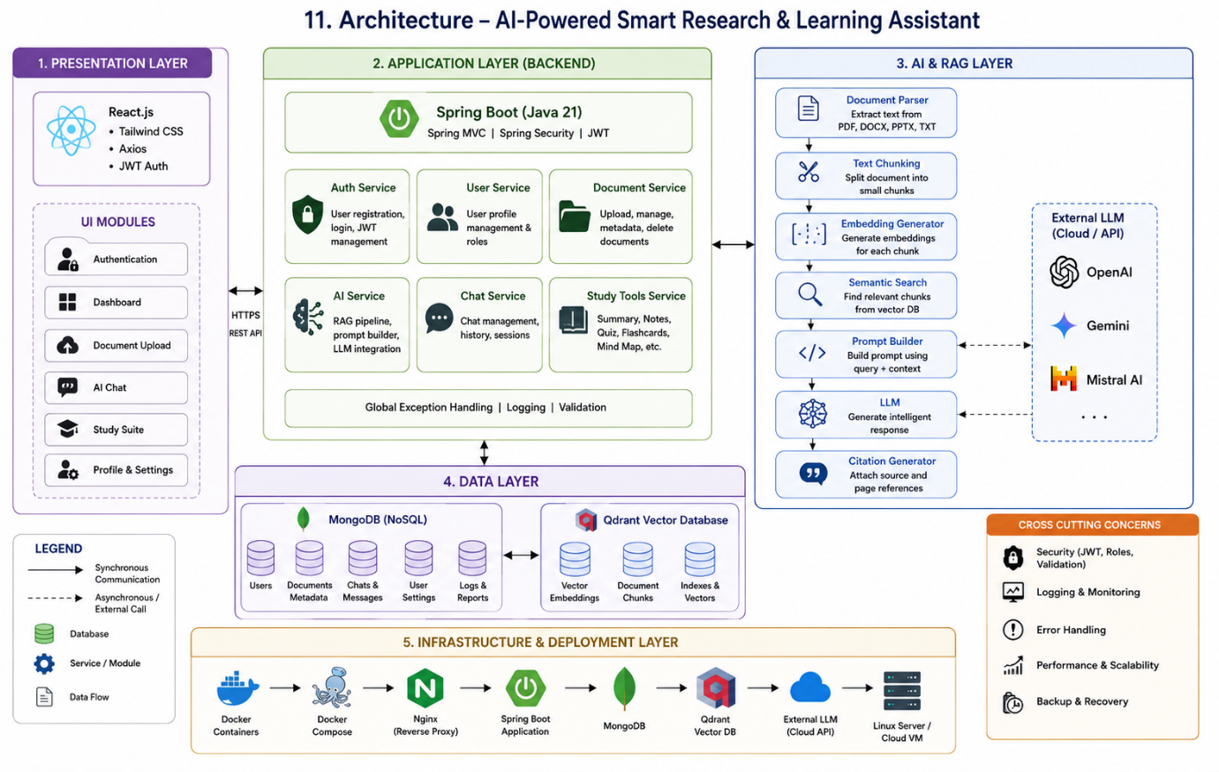

12. Technology Stack
The AI-Powered Smart Research & Learning Assistant is built using modern technologies that provide high performance, scalability, security, and seamless AI integration. The technology stack is divided into frontend, backend, AI, database, DevOps, and security components.

12.1 Frontend
The frontend provides an interactive and responsive user interface for document management and AI interactions.
Technology | Purpose
React.js | Build Single Page Application (SPA)
Tailwind CSS | Responsive UI Styling
Axios | REST API Communication
React Router | Client-side Routing
React Markdown | Render AI-generated Markdown Responses

12.2 Backend
The backend manages business logic, authentication, APIs, document processing, and AI integration.
Technology | Purpose
Java 21 | Programming Language
Spring Boot | Backend Framework
Spring MVC | REST API Development
Spring Security | Authentication & Authorization
JWT | Secure User Authentication
Maven | Dependency Management
Lombok | Reduce Boilerplate Code

12.3 Artificial Intelligence
The AI layer provides document understanding and intelligent response generation.
Technology | Purpose
Retrieval-Augmented Generation (RAG) | Context-aware AI responses
OpenAI / Gemini API | Large Language Model
Embedding Model | Convert text into vector embeddings
Prompt Engineering | Generate optimized AI prompts

12.4 Database
The system uses separate databases for application data and vector storage.
Technology | Purpose
MongoDB | Store users, documents, metadata, chat history
Qdrant | Store document embeddings and semantic vectors

12.5 DevOps & Deployment
Technology | Purpose
Docker | Containerization
Docker Compose | Multi-container deployment
Nginx | Reverse Proxy
Git | Version Control
GitHub | Source Code Repository

12.6 Security
Technology | Purpose
Spring Security | Application Security
JWT | Secure Authentication
BCrypt | Password Encryption
Role-Based Access Control (RBAC) | Authorization
HTTPS | Secure Communication
Input Validation | Prevent Invalid Requests

12.7 Technology Stack Summary
Layer | Technologies
Frontend | React.js, Tailwind CSS, Axios
Backend | Java 21, Spring Boot, Spring MVC, Maven
AI | RAG, OpenAI/Gemini API, Embedding Model
Database | MongoDB, Qdrant
Security | Spring Security, JWT, BCrypt, RBAC
DevOps | Docker, Docker Compose, Nginx, GitHub

13. REST API
The backend exposes RESTful APIs that allow the frontend to communicate with the application services. APIs are organized into five major modules: Authentication, Document Management, AI Chat, AI Study Suite, and User Profile.

13.1 Authentication APIs
Method | Endpoint | Description
POST | /api/auth/signup | Register a new user
POST | /api/auth/login | Authenticate user and generate JWT
POST | /api/auth/logout | Logout user
GET | /api/auth/me | Get logged-in user details
PUT | /api/auth/change-password | Change user password

13.2 Document APIs
Method | Endpoint | Description
POST | /api/documents/upload | Upload a document
GET | /api/documents | Get all uploaded documents
GET | /api/documents/{id} | Get document details
DELETE | /api/documents/{id} | Delete a document
GET | /api/documents/{id}/metadata | View document metadata

13.3 Chat (RAG) APIs
Method | Endpoint | Description
POST | /api/chat/ask | Ask AI questions about uploaded documents
GET | /api/chat/history | Retrieve chat history
GET | /api/chat/{chatId} | View specific conversation
DELETE | /api/chat/{chatId} | Delete chat history

13.4 AI Study Suite APIs
Method | Endpoint | Description
POST | /api/ai/summary | Generate document summary
POST | /api/ai/notes | Generate study notes
POST | /api/ai/quiz | Generate quiz
POST | /api/ai/flashcards | Generate flashcards
POST | /api/ai/mindmap | Generate mind map
POST | /api/ai/translate | Translate content
POST | /api/ai/eli5 | Simplify content (ELI5)
POST | /api/ai/tts | Convert text to speech

13.5 User Profile APIs
Method | Endpoint | Description
GET | /api/profile | Get user profile
PUT | /api/profile | Update profile
GET | /api/profile/settings | Get user settings
PUT | /api/profile/settings | Update user settings
GET | /api/profile/documents | View uploaded documents
GET | /api/profile/chats | View chat history

13.6 API Response Format

Success Response
{
"success": true,
"message": "Operation completed successfully.",
"data": {}
}

Error Response
{
"success": false,
"message": "Invalid request.",
"error": "Detailed error message"
}

13.7 REST API Summary
Module | Number of APIs
Authentication | 5
Document Management | 5
AI Chat (RAG) | 4
AI Study Suite | 8
User Profile | 6
Total | 28 APIs

14. Database Design
The AI-Powered Smart Research & Learning Assistant uses a hybrid database architecture consisting of MongoDB for application data and Qdrant Vector Database for semantic search. MongoDB stores structured data such as users, documents, chat history, and settings, while Qdrant stores vector embeddings generated from document chunks to enable Retrieval-Augmented Generation (RAG).

14.1 MongoDB Collections

1. Users Collection
Stores user account information.
Field | Type | Description
_id | ObjectId | Primary Key
name | String | User's Full Name
email | String | Unique Email Address
password | String | BCrypt Encrypted Password
role | String | USER / ADMIN
createdAt | Date | Account Creation Date
updatedAt | Date | Last Updated

2. Documents Collection
Stores uploaded document information.
Field | Type | Description
_id | ObjectId | Primary Key
userId | ObjectId | Owner of Document
fileName | String | Document Name
fileType | String | PDF/DOCX/PPTX/TXT
fileSize | Number | File Size
storagePath | String | File Location
uploadDate | Date | Upload Time
processingStatus | String | Uploaded / Processing / Indexed

3. Chat Collection
Stores chat sessions.
Field | Type | Description
_id | ObjectId | Primary Key
userId | ObjectId | User Reference
documentId | ObjectId | Document Reference
title | String | Chat Title
createdAt | Date | Creation Time

4. ChatMessages Collection
Stores individual messages.
Field | Type | Description
_id | ObjectId | Primary Key
chatId | ObjectId | Chat Reference
sender | String | User / AI
message | String | Chat Content
citations | Array | Source References
createdAt | Date | Timestamp

5. UserSettings Collection
Stores user preferences.
Field | Type | Description
_id | ObjectId | Primary Key
userId | ObjectId | User Reference
language | String | Preferred Language
theme | String | Light / Dark
notifications | Boolean | Notification Status

14.2 Qdrant Collection
Qdrant stores vector embeddings for semantic search.

Collection Name
document_embeddings
Field | Type | Description
id | UUID | Vector Identifier
documentId | String | Linked Document
chunkId | String | Chunk Identifier
embedding | Vector | Embedding Values
chunkText | String | Original Chunk
metadata | JSON | File Name, Page, User ID

14.3 Database Indexes
Indexes improve search performance and query efficiency.

MongoDB Indexes
Collection | Indexed Field
Users | email (Unique)
Documents | userId
Documents | uploadDate
Chat | userId
ChatMessages | chatId

Qdrant Index
- Vector Similarity Index
- Cosine Distance Metric
- Payload Index for documentId and userId

14.4 Relationships
The database follows the relationships below:
- One User → Many Documents
- One User → Many Chats
- One Chat → Many Chat Messages
- One Document → Many Vector Chunks
- One Document → Many AI Conversations

14.5 Database Summary
Database | Purpose
MongoDB | Users, Documents, Chats, Settings, Metadata
Qdrant | Vector Embeddings, Semantic Search, Document Chunks

15. Security
Security is a critical component of the AI-Powered Smart Research & Learning Assistant. The application implements modern authentication, authorization, encryption, and validation mechanisms to protect user data and prevent unauthorized access.

15.1 JWT Authentication
The application uses JSON Web Tokens (JWT) for secure authentication.

Features
- Token-based authentication
- Stateless session management
- Secure API access
- Token validation for protected endpoints
- Configurable token expiration

15.2 BCrypt Password Encryption
User passwords are never stored in plain text.

Features
- BCrypt hashing algorithm
- Salted password hashing
- Secure password verification
- Protection against password theft

15.3 Spring Security
Spring Security protects backend APIs from unauthorized access.

Features
- Authentication filters
- JWT request validation
- Protected REST endpoints
- Custom authentication handlers
- Exception handling

15.4 Authorization (RBAC)
The system follows Role-Based Access Control (RBAC).

Roles
User
- Upload documents
- Chat with AI
- Generate study materials
- Manage personal profile
Admin
- Manage users
- Manage documents
- Configure system settings
- Monitor application

15.5 Input Validation
All incoming requests are validated before processing.

Validation Includes
- Required field validation
- Email format validation
- Password strength validation
- File type validation
- File size validation
- Request parameter validation

15.6 Rate Limiting
Rate limiting protects APIs against abuse and excessive requests.

Features
- Limit API requests per user
- Prevent brute-force login attacks
- Reduce server overload
- Improve system availability

15.7 Additional Security Measures
The application also implements the following security best practices:
- HTTPS for secure communication
- CORS configuration
- Secure HTTP headers
- Exception handling without exposing sensitive data
- Input sanitization to reduce injection attacks
- Secure environment variables for API keys
- Access logging and monitoring

15.8 Security Summary
Security Component | Purpose
JWT | User Authentication
BCrypt | Password Encryption
Spring Security | API Protection
RBAC | Authorization
Input Validation | Prevent Invalid Requests
Rate Limiting | Prevent Abuse & Brute Force Attacks
HTTPS | Secure Data Transmission
Environment Variables | Secure Storage of Secrets

16. Non-Functional Requirements
Non-functional requirements define the quality attributes of the AI-Powered Smart Research & Learning Assistant. These requirements ensure that the system is reliable, secure, scalable, maintainable, and capable of providing a smooth user experience.

16.1 Performance
The application should deliver fast and responsive performance for all users.

Requirements
- Average API response time should be less than 2 seconds under normal load.
- AI responses should be generated within 5–10 seconds, depending on the LLM provider.
- Document upload should begin processing immediately after successful upload.
- Semantic search should retrieve relevant document chunks with minimal latency.
- The system should efficiently process large documents through chunking and indexing.

16.2 Scalability
The system should support future growth without major architectural changes.

Requirements
- Support increasing numbers of users and uploaded documents.
- Allow horizontal scaling of backend services.
- Support deployment using Docker containers.
- Enable easy integration of additional AI models and services.
- Allow future migration to cloud infrastructure.

16.3 Availability
The application should remain accessible whenever users need it.

Requirements
- Target system availability of 99% or higher.
- Ensure minimal downtime during maintenance.
- Handle unexpected failures gracefully.
- Provide reliable access to uploaded documents and AI services.

16.4 Reliability
The system should consistently perform expected operations without failure.

Requirements
- Prevent data loss during document processing.
- Maintain accurate chat history.
- Ensure successful storage of uploaded documents.
- Provide consistent AI responses based on retrieved document context.
- Recover safely from unexpected errors.

16.5 Security
User data and application resources must be protected against unauthorized access.

Requirements
- Secure authentication using JWT.
- Password encryption using BCrypt.
- Role-Based Access Control (RBAC).
- HTTPS for secure communication.
- Input validation and sanitization.
- Secure storage of API keys and environment variables.

16.6 Maintainability
The application should be easy to maintain and extend.

Requirements
- Modular Spring Boot architecture.
- Layered project structure.
- Reusable service components.
- Well-documented REST APIs.
- Consistent coding standards.
- Easy integration of new AI features.

16.7 Accessibility
The application should be usable by a wide range of users.

Requirements
- Responsive design for desktop, tablet, and mobile devices.
- Simple and intuitive user interface.
- Readable typography and color contrast.
- Easy navigation between modules.
- User-friendly error messages and feedback.

16.8 Compatibility
The application should function across different platforms and browsers.

Requirements
- Support modern web browsers (Chrome, Edge, Firefox, Safari).
- Compatible with Windows, Linux, and macOS.
- Responsive across multiple screen sizes.
- Backend APIs accessible from different frontend clients.

16.9 Non-Functional Requirement Summary
Requirement | Description
Performance | Fast response time and efficient document processing
Scalability | Supports increasing users and future expansion
Availability | High uptime with minimal downtime
Reliability | Accurate and consistent system behavior
Security | Secure authentication, authorization, and data protection
Maintainability | Modular and easy-to-maintain architecture
Accessibility | Responsive and user-friendly interface
Compatibility | Cross-browser and cross-platform support

17. Deployment
The AI-Powered Smart Research & Learning Assistant is designed for containerized deployment using Docker. The application follows a multi-tier deployment architecture consisting of a React frontend, Spring Boot backend, MongoDB, Qdrant Vector Database, and an external Large Language Model (LLM) API.

17.1 Deployment Architecture
The deployment architecture consists of the following components:
- Client Browser
- Nginx Reverse Proxy
- React Frontend
- Spring Boot Backend
- MongoDB Database
- Qdrant Vector Database
- External LLM API
- Docker & Docker Compose

17.2 Docker
Docker is used to package each component into isolated containers.

Benefits
- Consistent deployment across environments.
- Simplified application setup.
- Easy dependency management.
- Improved portability.
- Scalable container-based architecture.

17.3 Docker Compose
Docker Compose manages multiple containers as a single application.

Services
- React Frontend
- Spring Boot Backend
- MongoDB
- Qdrant
- Nginx

Benefits
- One-command deployment.
- Automatic service networking.
- Centralized configuration.
- Simplified local development.

17.4 Nginx Reverse Proxy
Nginx acts as the entry point for incoming client requests.

Responsibilities
- Serve the React frontend.
- Reverse proxy API requests to Spring Boot.
- Enable HTTPS support.
- Improve performance through caching.
- Handle load balancing (future enhancement).

17.5 Production Architecture
The production deployment follows the architecture below:
Client Browser
│
▼
Nginx
│
▼
React Frontend
│
REST API (HTTPS)
│
▼
Spring Boot Backend
│ │
│ ├────────► External LLM API
│
├────────► MongoDB
│
└────────► Qdrant Vector Database

17.6 Environment Variables
Sensitive information is stored using environment variables instead of hardcoding values.

Examples
Variable | Description
MONGODB_URI | MongoDB Connection String
QDRANT_URL | Qdrant Server URL
JWT_SECRET | JWT Signing Secret
JWT_EXPIRATION | JWT Token Expiration Time
LLM_API_KEY | API Key for LLM Provider
LLM_API_URL | LLM Service Endpoint
SERVER_PORT | Spring Boot Server Port

17.7 Deployment Steps
- Clone the project repository.
- Configure the environment variables.
- Start MongoDB and Qdrant services.
- Build Docker images.
- Launch all containers using Docker Compose.
- Configure Nginx as a reverse proxy.
- Verify API connectivity and frontend access.
- Deploy the application to the production server.

17.8 Deployment Summary
Component | Technology
Frontend | React.js
Backend | Spring Boot
Database | MongoDB
Vector Database | Qdrant
Reverse Proxy | Nginx
Containerization | Docker
Orchestration | Docker Compose
AI Service | External LLM API (OpenAI/Gemini)

